SUPPLEMENTARY MATERIALS

SUPPLEMENTARY RESULTS
Table S1. Change in 10-year stage I incidence by cancer type (per 100,000).
Cancer type | SoC | SoC + MCED | Absolute change | Relative change
Breast | 1,011 | 1,050 | +39 | +4%
Cervical | 15 | 35 | +20 | +133%
Colorectal | 231 | 263 | +32 | +14%
Endometrial | 289 | 304 | +15 | +5%
Esophageal | 20 | 20 | 0 | 0%
Gastric | 53 | 66 | +13 | +25%
Head and Neck | 111 | 159 | +48 | +43%
Kidney | 238 | 238 | 0 | 0%
Liver | 108 | 142 | +34 | +31%
Lung | 336 | 376 | +40 | +12%
Ovarian | 27 | 27 | 0 | 0%
Pancreatic | 48 | 79 | +31 | +65%
Prostate | 449 | 457 | +8 | +2%
Urinary Bladder | 132 | 148 | +16 | +12%
Total | 3,068 | 3,364 | +296 | +10%
Total excluding breast and prostate cancer | 1,608 | 1,857 | +249 | +15%
Total for cancer types with recommended screening | 1,593 | 1,724 | +131 | +8%
Total for cancer types without recommended screening | 1,475 | 1,640 | +165 | +11%
Abbreviations: MCED, multi-cancer early detection; SoC, standard-of-care.
Table S2. Change in 10-year stage II incidence by cancer type (per 100,000).
Cancer type | SoC | SoC + MCED | Absolute change | Relative change
Breast | 416 | 446 | +30 | +7%
Cervical | 9 | 14 | +5 | +56%
Colorectal | 244 | 354 | +110 | +45%
Endometrial | 22 | 24 | +2 | +9%
Esophageal | 22 | 25 | +3 | +14%
Gastric | 30 | 50 | +20 | +67%
Head and Neck | 55 | 73 | +18 | +33%
Kidney | 30 | 45 | +15 | +50%
Liver | 53 | 100 | +47 | +89%
Lung | 117 | 210 | +93 | +79%
Ovarian | 13 | 13 | 0 | 0%
Pancreatic | 80 | 113 | +33 | +41%
Prostate | 914 | 922 | +8 | +1%
Urinary Bladder | 74 | 102 | +28 | +38%
Total | 2,079 | 2,491 | +412 | +20%
Total excluding breast and prostate cancer | 749 | 1,123 | +374 | +50%
Total for cancer types with recommended screening | 786 | 1,024 | +238 | +30%
Total for cancer types without recommended screening | 1,293 | 1,467 | +174 | +13%
Abbreviations: MCED, multi-cancer early detection; SoC, standard-of-care.
Table S3. Change in 10-year stage III incidence by cancer type (per 100,000).
Cancer type | SoC | SoC + MCED | Absolute change | Relative change
Breast | 147 | 150 | +3 | +2%
Cervical | 12 | 7 | -5 | -42%
Colorectal | 256 | 286 | +30 | +12%
Endometrial | 56 | 63 | +7 | +12%
Esophageal | 34 | 57 | +23 | +68%
Gastric | 37 | 59 | +22 | +59%
Head and Neck | 60 | 80 | +20 | +33%
Kidney | 69 | 77 | +8 | +12%
Liver | 50 | 31 | -19 | -38%
Lung | 308 | 596 | +288 | +94%
Ovarian | 55 | 71 | +16 | +29%
Pancreatic | 42 | 114 | +72 | +171%
Prostate | 260 | 260 | 0 | 0%
Urinary Bladder | 28 | 45 | +17 | +61%
Total | 1,414 | 1,896 | 482 | +34%
Total excluding breast and prostate cancer | 1,007 | 1,486 | +479 | +48%
Total for cancer types with recommended screening | 723 | 1,039 | +316 | +44%
Total for cancer types without recommended screening | 691 | 857 | +166 | +24%
Abbreviations: MCED, multi-cancer early detection; SoC, standard-of-care.

Table S4. Detailed description of scenarios explored in the scenario analysis.
Scenario name | Dwell times | MCED uptake | MCED adherence | MCED sensitivities discounting | MCED testing strategy | Time horizon (years)
Base case
 | Base case | 100% | 100% | None | Every year starting in Year 1 | 10
MCED testing interval
Biennial | Base case | 100% | 100% | None | Every 2 years starting in Year 1 | 10
Triennial | Base case | 100% | 100% | None | Every 3 years starting in Year 1 | 10
MCED uptake
90% | Base case | 90% | 100% | None | Every year starting in Year 1 | 10
70% | Base case | 70% | 100% | None | Every year starting in Year 1 | 10
50% | Base case | 50% | 100% | None | Every year starting in Year 1 | 10
MCED adherence
90% | Base case | 100% | 90% | None | Every year starting in Year 1 | 10
70% | Base case | 100% | 70% | None | Every year starting in Year 1 | 10
50% | Base case | 100% | 50% | None | Every year starting in Year 1 | 10
MCED sensitivities discounting
80% | Base case | 100% | 100% | 80% | Every year starting in Year 1 | 10
Dwell times
Slower | Base case × 1.25 | 100% | 100% | None | Every year starting in Year 1 | 10
Faster | Base case × 0.75 | 100% | 100% | None | Every year starting in Year 1 | 10
Time horizon
20 years | Base case | 100% | 100% | None | Every year starting in Year 1 | 20
50 years | Base case | 100% | 100% | None | Every year starting in Year 1 | 50
One-time MCED testing
 | Base case | 100% | 100% | None | Once in Year 1 | 10
Abbreviations: MCED, multi-cancer early detection.

(A)
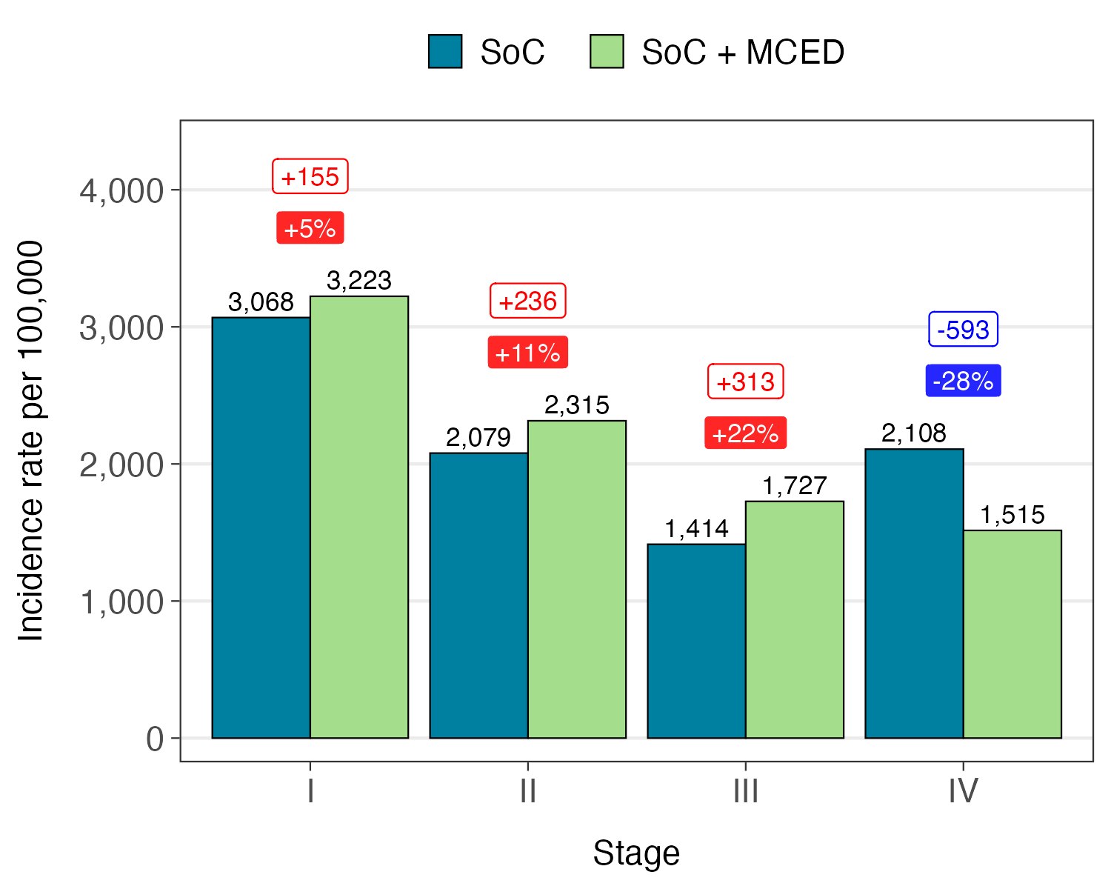
(B)
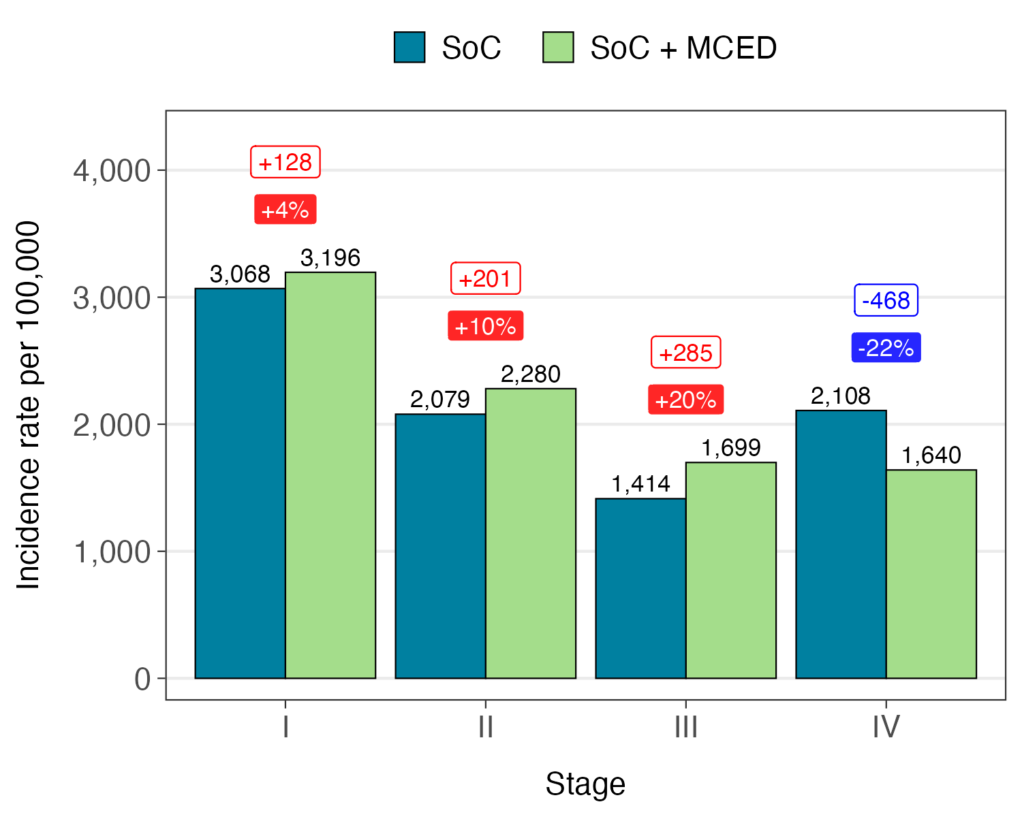
Figure S1. (A) 10-year stage shift with biennial MCED testing. (B) 10-year stage shift with triennial MCED testing. Abbreviations: MCED, multi-cancer early detection; SoC, standard-of-care.

(A)
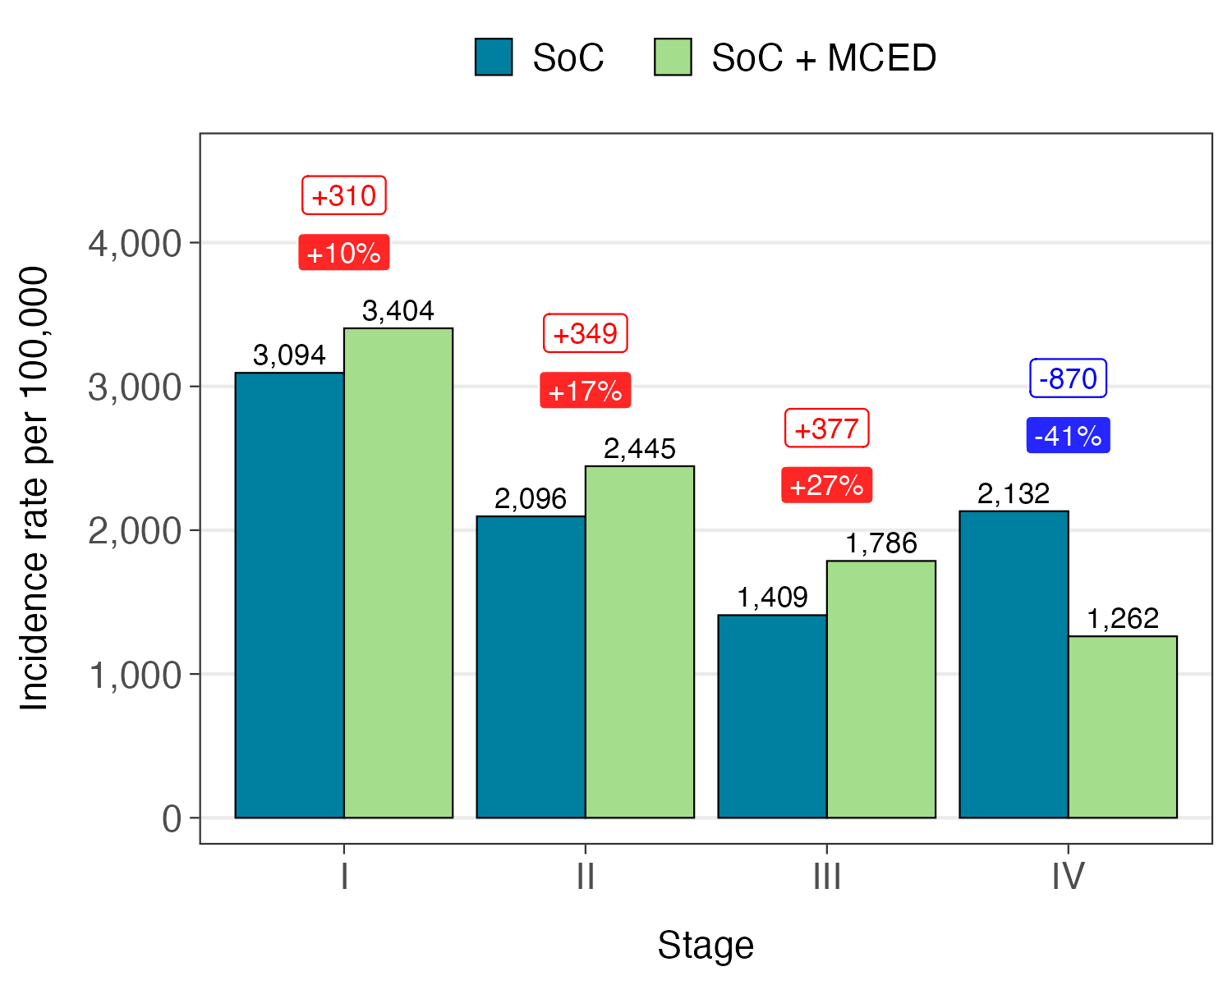
(B)
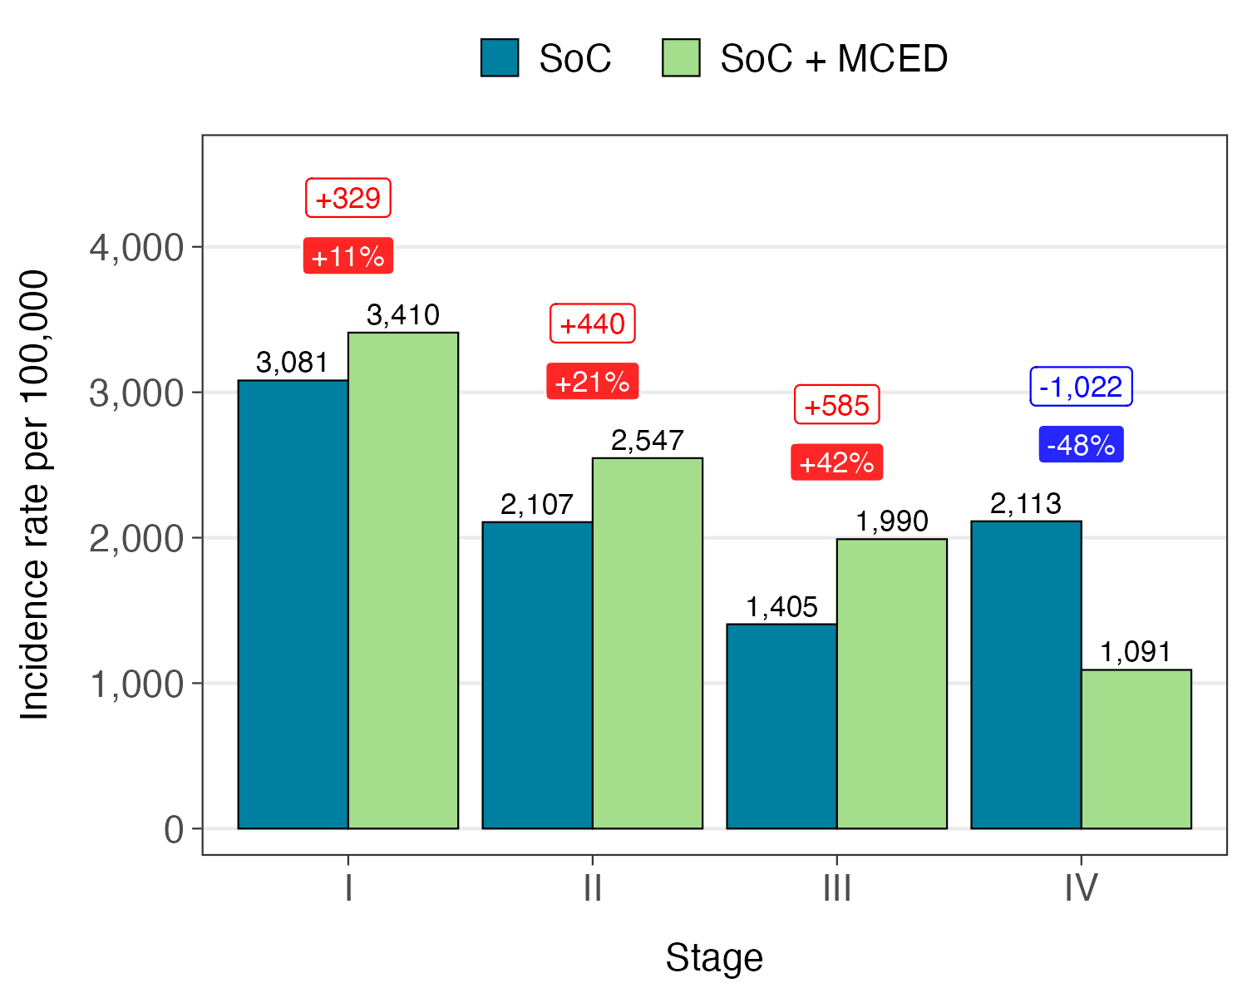
Figure S2. (A) 10-year stage shift with slower dwell times. (B) 10-year stage shift with faster dwell times. Abbreviations: MCED, multi-cancer early detection; SoC, standard-of-care.

(A)
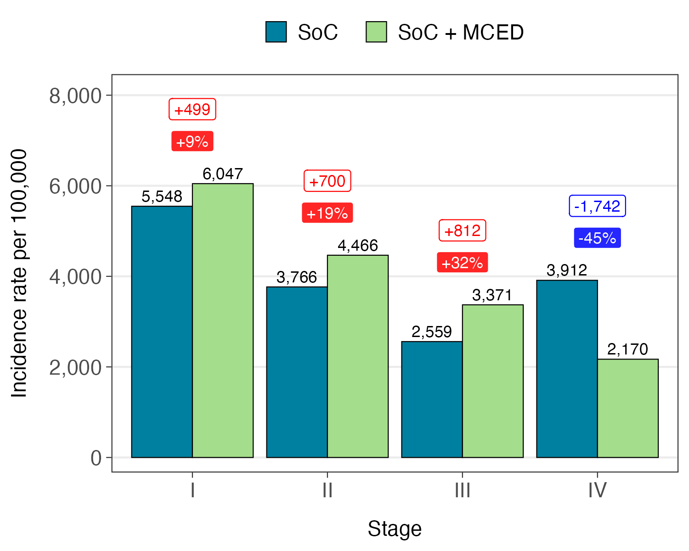
(B)
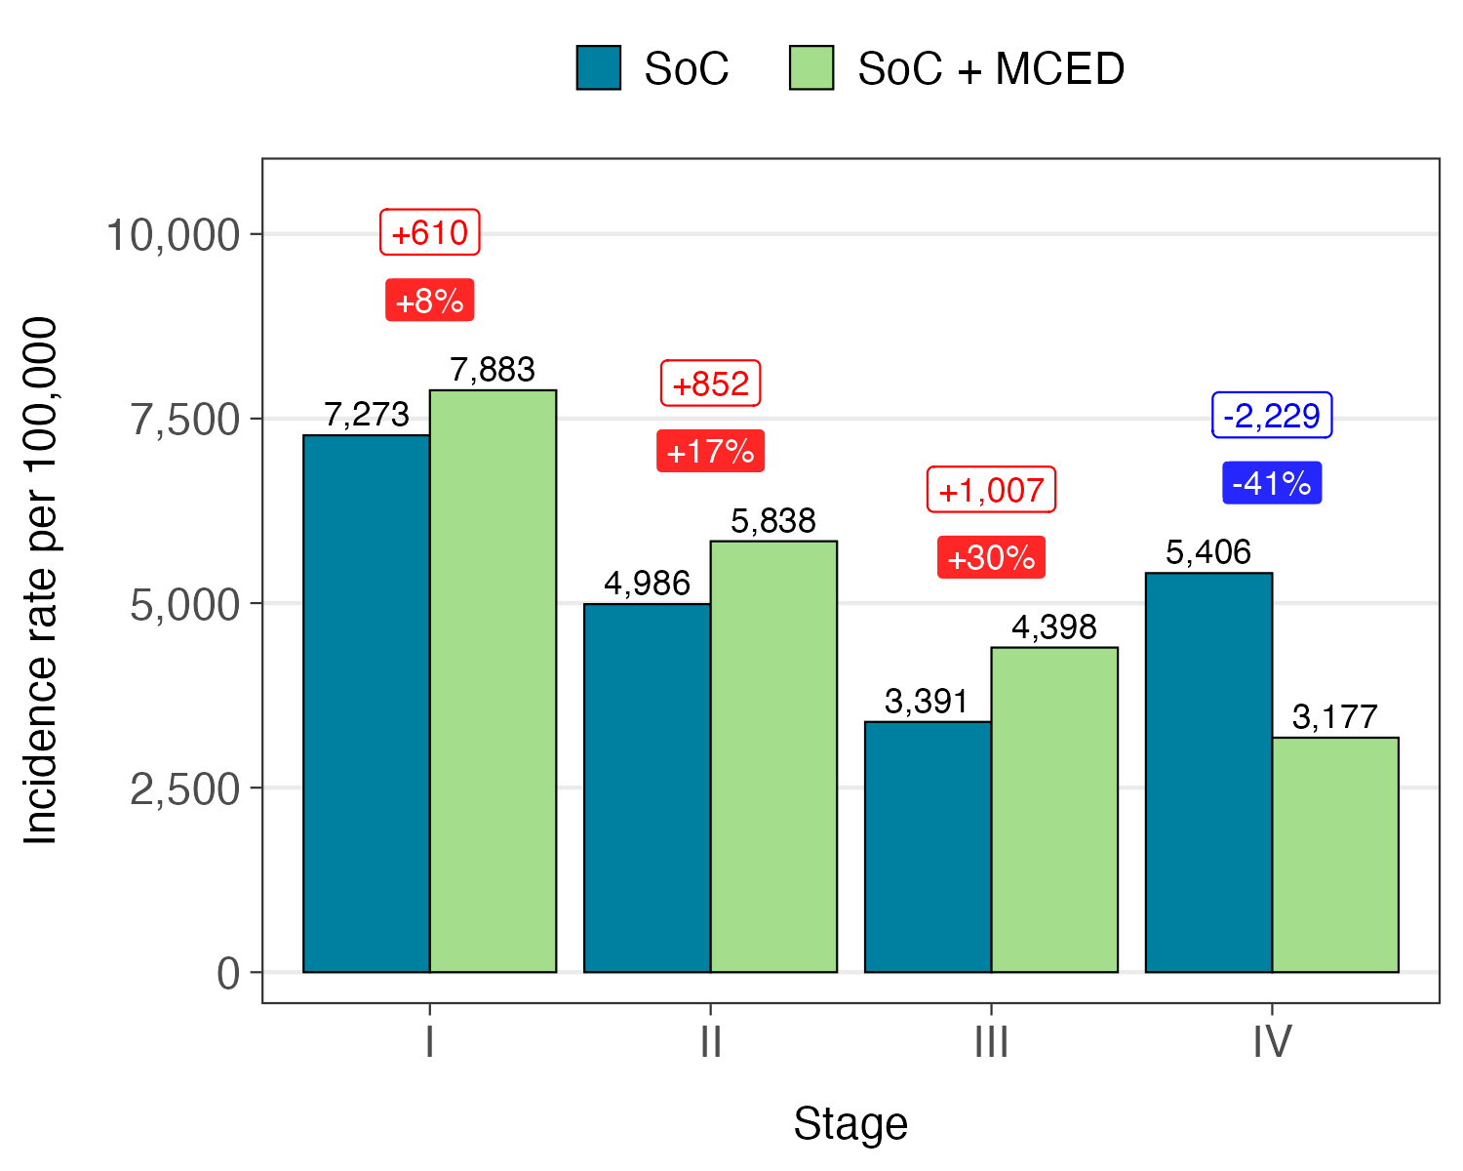
Figure S3. (A) 20-year stage shift. (B) 50-year stage shift. Abbreviations: MCED, multi-cancer early detection; SoC, standard-of-care.

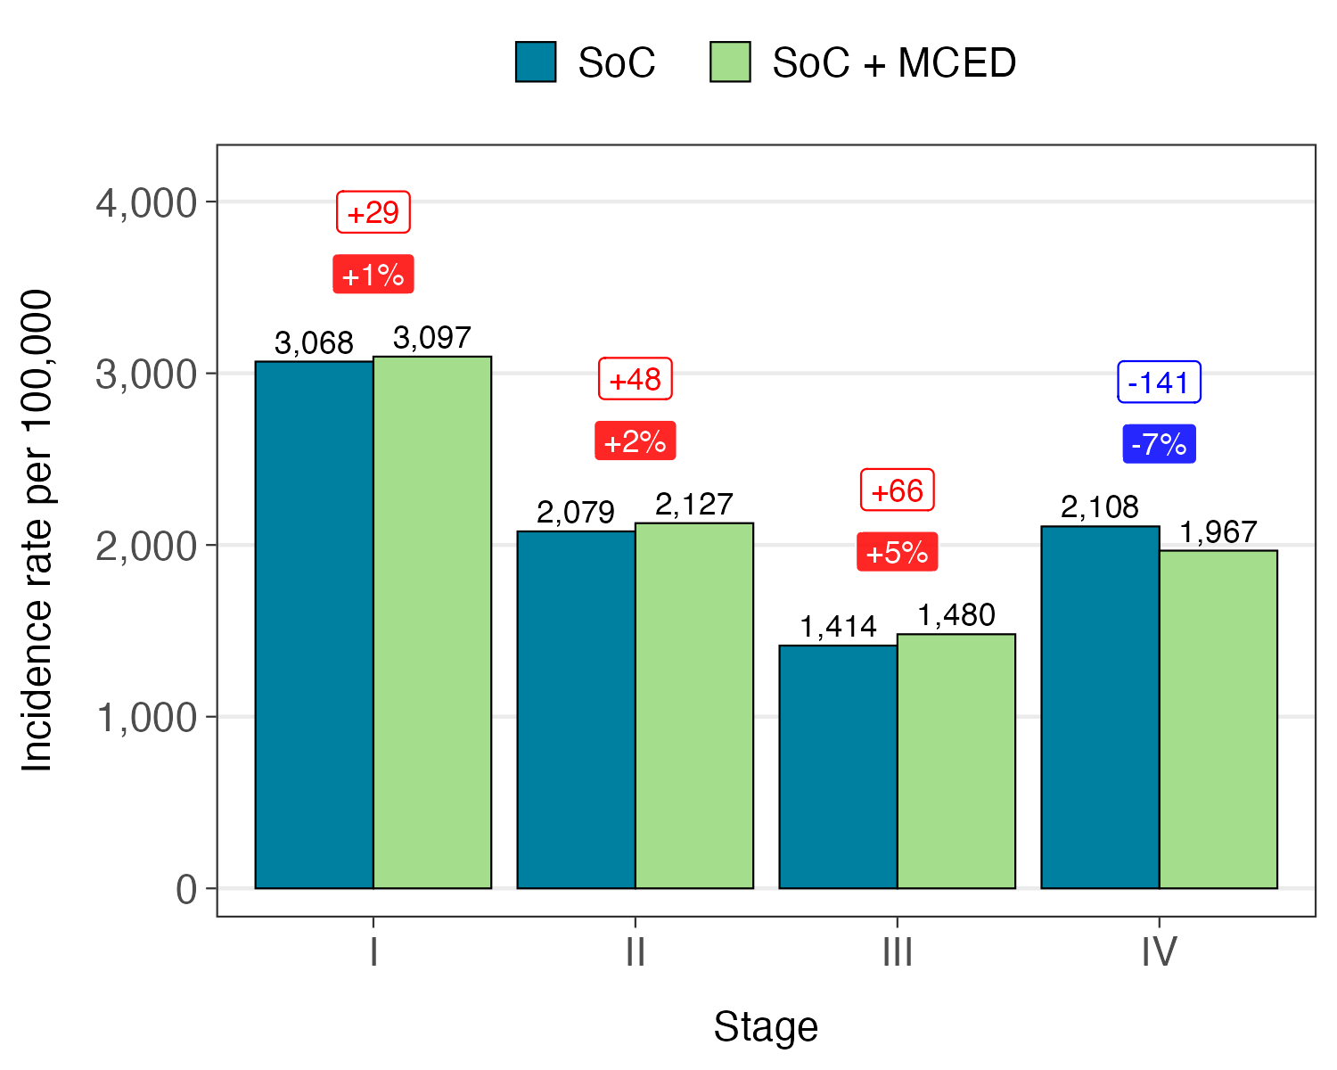
Figure S4. (A) 10-year stage shift with one-time MCED testing. Abbreviations: MCED, multi-cancer early detection; SoC, standard-of-care.

TECHNICAL SUPPLEMENT FOR SiMCED
The following information is intended to supplement the methods outlined in the manuscript.
SiMCED was implemented in C++. Figure S6 is a high-level schematic of the model.
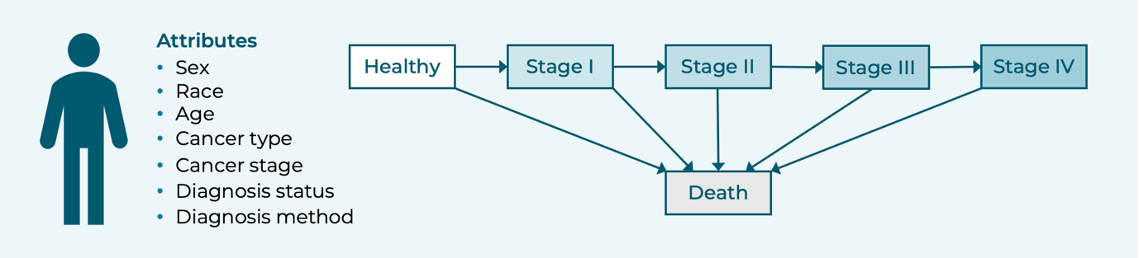
Figure S6. High-level model schematic.
Initialization of the Simulated Cohort
A simulated individual is initialized with the following attributes:
- Sex: Female / Male
- Race: Asian / Black / Hispanic / White / Others
- Age: Single year of age between 50 and 84
Sex, race, and age are jointly sampled from an empirical distribution representing the US general population in 2015. The data source is CDC WONDER.¹
Discrete Event Simulation
An individual’s life history is described by an “event list.” There are seven event types:
- Birth
- Oncogenesis
- Cancer progression
- SoC diagnosis
- MCED diagnosis
- Death
The following describes how the time to each event type is generated.
Death. The age at all-cause death is determined by sampling whether the individual survives each age after their age at initialization. The data source is CDC Life Tables for 2021,² which is stratified by sex, race, and age. The maximum lifespan is 100 years.
Oncogenesis. The time to oncogenesis from the moment the individual attains their current 5-year age group is sampled from an exponential random variable with a rate given by the incidence rate for their sex, race, and age group; and resampled whenever the individual ages into the next age group. Incidence rates are obtained from calibration of the initial estimates provided by the unobserved incidence methodology.^{3,4} The cancer type with the earliest time of oncogenesis before the time of death is the cancer type that the individual develops.
After developing cancer, the next event is determined by whichever has the earliest time of occurrence among cancer progression, SoC diagnosis, MCED diagnosis, and death.
Cancer progression. The time to cancer progression from the moment the individual attains their current cancer stage is sampled from an exponential random variable with a rate given by the dwell time of the cancer type and the current cancer stage (Table 1 of the manuscript).
SoC diagnosis. The time to SoC diagnosis from the time the individual attains their current cancer stage is sampled as an exponential random variable with a rate given by the incidence rate for their sex, race, 5-year age group, cancer type, and cancer stage. Incidence rates are obtained from calibration of the initial estimates provided by the unobserved incidence methodology.^{3,4}
MCED diagnosis. MCED testing is administered at deterministic time points as determined by the testing interval (I). The prevalent round of MCED testing occurs at model time T = 0. For T > 0 and not integer, representing the time at which an individual attains a new cancer stage, the next time point at which testing occurs is given by T’ = ⌈T / I⌉ × I, where ⌈ · ⌉ is the ceiling operator, followed by testing at T’ + I, T’ + 2I, T’ + 3I, etc. The individual must be aged <85 years at the time of testing. The probability of the MCED test detecting cancer is given by the sensitivity for the cancer type and current cancer stage.
Calibration
For each cancer type, we used the outputs from the unobserved incidence methodology as initial estimates for the rate of oncogenesis, the initial prevalence by stage, and the rate of SoC diagnosis by stage. These parameters were subsequently calibrated at the cancer type and stage level, maintaining the original ratios between different combinations of sex, race, and age. The calibration target was annual incidence rates of diagnosis averaged over calendar years 2015-2021.⁵
Calibration was performed on an open cohort version of the model where individuals aged 40-49 years were also initialized and “entered” the model when they attained 50 years of age. For example, an individual initialized at age 45 would enter the model at T = 5. Thus, the model replicates population dynamics that may influence cancer diagnosis rates over the calibration period.
Figure S7 compares final model outputs against SEER-reported incidence.
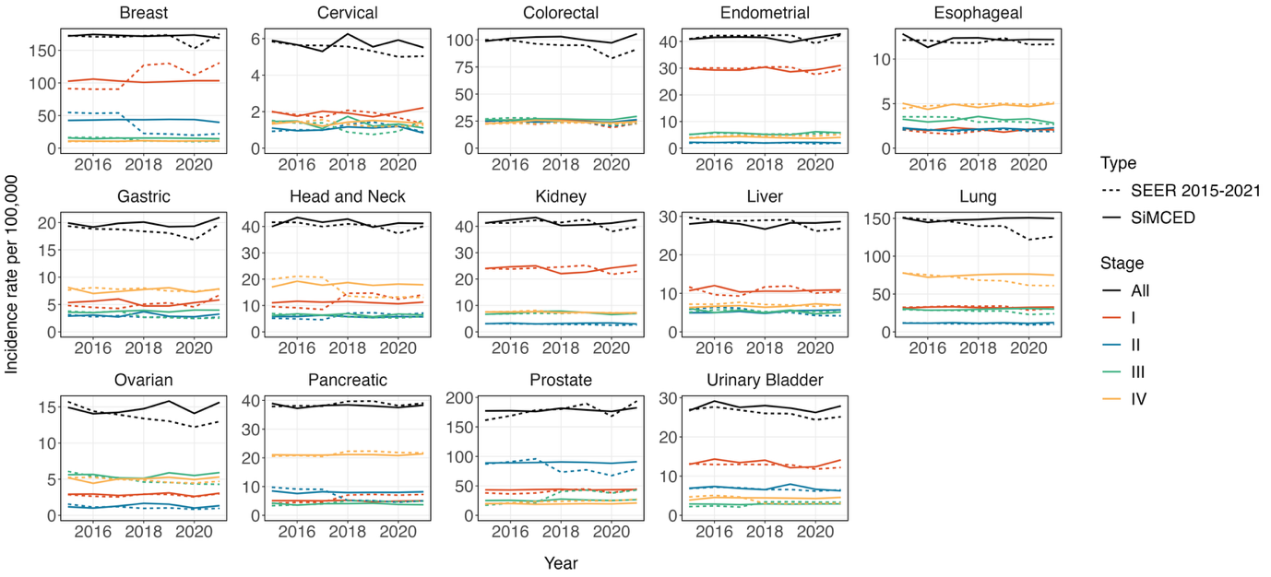
Figure S7. Comparison of SEER-reported incidence and SiMCED-generated incidence by cancer type and stage. Abbreviations: SEER, Surveillance, Epidemiology, and End Results; SiMCED, Simulation Model for MCED.

REFERENCES
1. Centers for Disease Control and Prevention. Single-Race Population Estimates. Accessed July 7, 2025. https://wonder.cdc.gov/single-race-population.html
2. Arias E, Xu J, Tejada-Vera B, Bastian B. National Vital Statistics Reports Volume 73, Number 7 August 21, 2024. Published online 2021.
3. ElHabr A, Tyson C, Cao X, et al. EPH232 The Large Hidden Prevalence Rate of Cancer Using Backward Induction Method Reveals Screening Opportunity in Earlier Stages. Value Health. 2023;26:S205. doi:10.1016/j.jval.2023.03.2578
4. Chhatwal J, ElHabr A, Tyson C, et al. Correlation of unobserved incidence of cancer in earlier stages with the observed incidence. J Clin Oncol. 2023;41(16_suppl):10634-10634. doi:10.1200/JCO.2023.41.16_suppl.10634
5. National Cancer Institute, DCCPS, Surveillance Research Program. Surveillance Research Program, National Cancer Institute SEER*Stat software. Published online November 2023. seer.cancer.gov/seerstat

